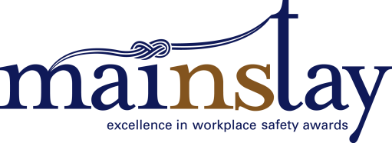 Application: Employer Return to Work Champion

Employer name:
Workplace Address:
Town/City/Community:
Postal Code:
This award recognizes an organization demonstrating best practice in the implementation of an effective return-to-work program. An Employer Return-to-Work Champion may be awarded in each of the four Nova Scotia regions (Cape Breton, HRM, South Shore/Valley, Central North Shore).
Assessment Criteria: Responses
Please respond to each question in the field provided. Please keep your responses brief – generally allow about a half single-spaced page (250 words) for each response.
1. How is leadership’s commitment to return to work demonstrated in the organization?

2. Discuss any relevant history of workplace injury prior to implementing a return-to-work program, and the results after implementation – for example, improvements in claims-cost experience.

3. To what extent was the return-to-work program developed in consultation with workplace parties (eg. employees, unions, JOHS committees, etc.) and, where appropriate, with outside organizations?

4. Describe the organization’s return-to-work relationships with both employees and health care providers.

5. How is the return-to-work program integrated into the overall occupational health and safety operations of the company?

6. What effect has return-to-work had on your business?

Your application must also include:
- A copy of your organization’s occupational health and safety code of practice or program as required under Sections 27 and 28 of the Occupational Health and Safety Act (if applicable).
- A copy of your Return-to-Work/Stay-at-Work Program.
Award finalists will be visited by members of the judging panel to verify claims made in the proposals, and to gain further context.

