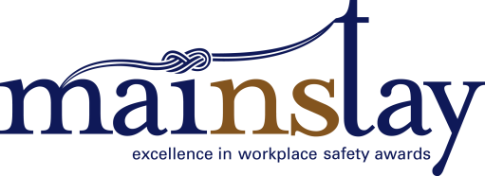 Application: Employer Safety Champion

Employer name:
Workplace Address:
Town/City/Community:
Postal Code:
This award recognizes an employer who has demonstrated an exemplary health and safety program and proven injury prevention track record in their workplace. An Employer Safety Champion may be awarded in each of the four Nova Scotia regions (Cape Breton, HRM, South Shore/Valley, Central North Shore).
A successful occupational health and safety program demonstrates that all elements function according to fundamental rules, that analysis can be completed with a consistent auditing approach, and that each part of the overall program can be studied.
Short term goals are continually set and met and are seen as contributing to the higher goal of eliminating risks to health and safety, improving the viability of the business and contributing to the well-being of anyone affected by the business’ operations.
Assessment Criteria: Responses
Please respond to each question in the field provided. Please keep your responses brief – generally allow about a half single-spaced page (250 words) for each.
1. How is leadership’s commitment to return to work demonstrated in the organization?

2. Show how your organization goes above and beyond minimum safety compliance relative to your industry. You may attach examples where appropriate.

3. To what extent was your safety policy and program developed in consultation with workplace parties (eg. employees, unions, JOHS committees, etc.) and, where appropriate, with outside organizations?

4. To what extent is there a commitment to safety at all levels of the company, from the boardroom to operations?

5. Describe your organization’s approach to identifying hazards and assessing the risk that they may result in an injury or illness.

6. How do you consider all possible risk control measures when developing or improving the health and safety practice(s) in your workplace?

7. How do you record your health and safety work practices? How can employees access them?

8. How do you communicate to employees about the health and safety work practices? For example, how were they trained in, or made aware of, these practices?

9. Beyond safety, what effect has your health and safety track record had on your business? How has it improved productivity, morale, increased consultation in your workplace, employee retention/recruitment and/or profitability?

Your application must also include:
- A copy of your organization’s occupational health and safety code of practice or program as required under Sections 27 and 28 of the Occupational Health and Safety Act (if applicable).
- A photo of posted occupational health and safety materials in your workplace as required under Sections 9(2), 37, 38 and 39 of the Occupational Health & Safety Act.
- Evidence of a third party audit of your Health and Safety Program, conducted within the previous 2 years.
Award finalists will be visited by members of the judging panel to verify claims made in the proposals, and to gain further context.

