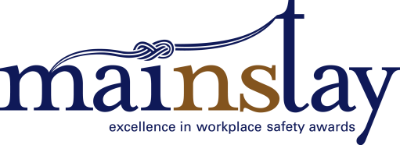 Application: Health and Safety Educator Award

Applicant name:
Organization:
Phone:
E-mail:
Name of Nominee:
Title/Position:
Organization:
Telephone:
E-mail address:
Work address:
The Health and Safety Educator Award is awarded to an educator who has demonstrated a commitment to the promotion and advancement of workplace health and safety. It is open to workplace and industry educators, associations, community-based educators, teachers of students in grades 9-12, and instructors and teachers at private colleges, universities and the Nova Scotia Community College.
Assessment Criteria: Responses
Please respond to each question in the field provided to effectively demonstrate how the nominee has met the criteria. Please keep your responses brief – generally allow about a half single-spaced page (250 words) for each response.
1. How does the nominee consistently demonstrate commitment to creating a culture of workplace health, safety and injury prevention for Nova Scotian students, workers or workplaces? Provide two examples.

2. How does the nominee promote and enhance the experience of learning workplace health and safety content? Describe his or her teaching methods.

3. How does the nominee personally model health and safe behaviour at the workplace or school, and how does he/she place a high expectation on learners to model the same behaviour.

4. How does the nominee encourage and support additional learning understanding of the subject material? Describe in detail.

5. How does the nominee go above and beyond the curriculum requirements, learning outlines, or service-delivery expectations of the program/course to support effective learning outcomes? Provide at least three examples.

Your application must also include:
- A copy of your organization’s occupational health and safety code of practice or program as required under Section 38 of the Occupational Health & Safety Act.
- An outline of your training program curriculum.
Award finalists may be visited by members of the judging panel to verify claims made in the proposals, and to gain further context.

